Use-Case Realization Report
Delete Question

Issue <1.0>
Revision History
Date | Issue | Description | Author
<dd/mmm/yy> | <x.x> | <details> | <name>

Table of Contents
1. Brief Description 4
2. Flow of Events 4
3. Interaction Diagrams 4
3.1 Collaboration Diagram for Delete Question 4
3.2 Sequence Diagram for Delete Question 5
4. Participating Objects 5
5. Class Diagrams 6
5.1 Class Diagram for Delete Question 6
6. Derived Requirements 6

Use-Case Realization Report
Delete Question

Brief Description

Flow of Events
[enter the flow of events here; you can use subsections to structure the text]

Interaction Diagrams

Collaboration Diagram for Delete Question
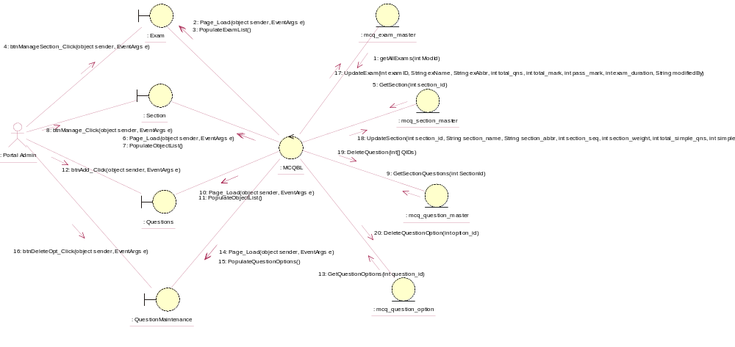

Sequence Diagram for Delete Question
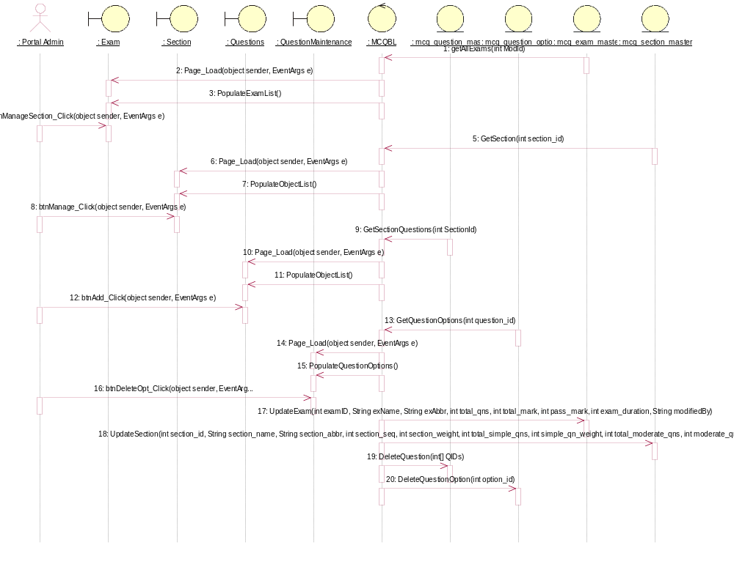

Participating Objects
: Exam

: mcq_exam_master

: mcq_question_master

: mcq_question_option

: mcq_section_master

: MCQBL

: Portal Admin

: QuestionMaintenance

: Questions

: Section

Class Diagrams

Class Diagram for Delete Question
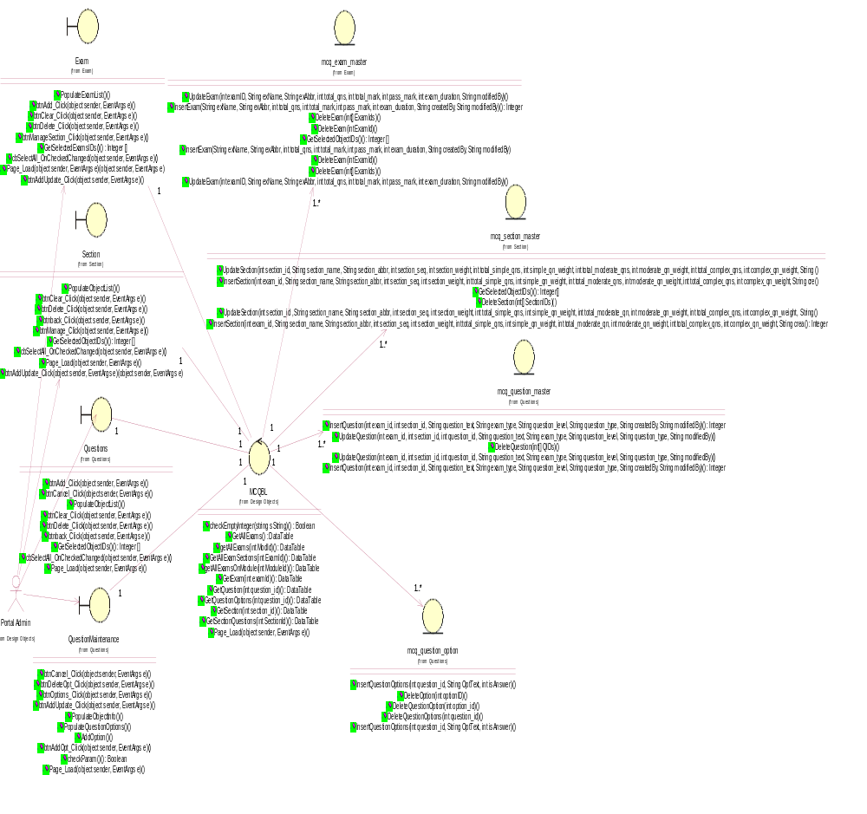

Derived Requirements
[enter the derived requirements here]

